Muppets/Sesame Street
Checklist
Updated 6/12/19
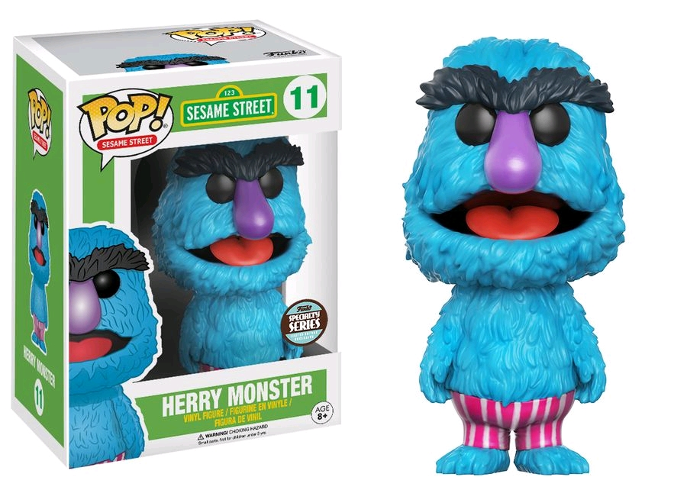

MUPPETS SERIES
01 Kermit
01 Metallic Kermit (SDCC 13)
01 Muppets Most Wanted Kermit
02 Miss Piggy
02 Metallic Miss Piggy (SDCC 13)
02 Muppets Most Wanted Miss Piggy
03 Gonzo
04 Fozzie Bear
05 Animal
05 Metallic Animal (SDCC 13)
05 Muppets Most Wanted Animal
05 Flocked Animal (Funko-Shop)
06 Dr. Teeth
07 Mahna Mahna
08 Snowth
09 Sam the Eagle
10 Swedish Chef
11 Superhero Kermit
MUPPETS COMBO PACKS
Metallic Mahna Mahna and Snowths (SDCC 13)
SESAME STREET SERIES
01 Super Grover (Toy Tokyo 1st to Market
01 Super Grover (Mass release)
01 Flocked Super Grover (Funko-Shop)
02 Cookie Monster
02 Flocked Cookie Monster (NYCC 15)
03 Oscar the Grouch
03 Orange Oscar the Grouch (EE)
04 Bert
04 Flocked Bert
05 Ernie
05 Flocked Ernie
06 6” Mr. Snuffleupagus
06 6” Flocked Mr. Snuffleupagus
(SDCC 15)
07 The Count
08 Elmo
08 Flocked Elmo (BN)
09 Grover
10 Big Bird
10 Flocked Big Bird (BN)
11 Herry Monster (Spec Series)

