PopVinyls.com ReAction List

Revised December 2014
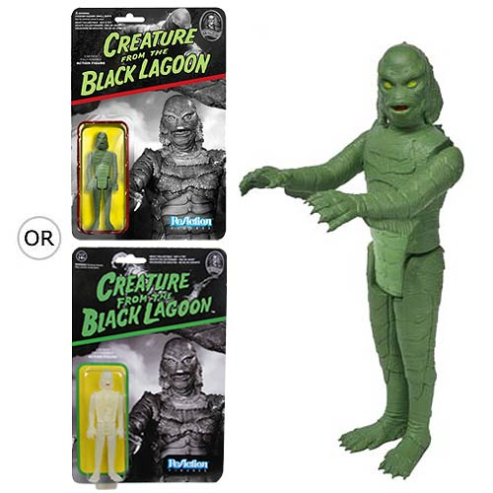
ALIEN REACTION FIGURES
Series 1
Alien
Ash
Dallas
Kane in Space suit
Ripley
Alien: Deep Space SDCC 2014
(these figures came in “blind box” Alien Egg)
Alien
Crystal Alien
Kane
Crystal Kane
Ripley
Crystal Ripley
Space Suit Ripley
Crystal Space Suit Ripley
Series 2
Metallic Alien
Chestburster Kane
Facehugger Kane
Space Suit Ripley
BACK TO THE FUTURE REACTION FIGURES
Marty McFly
Doc Emmett Brown
Biff Tannen
George McFly
Marty McFly with Dog (JAPAN MAGAZINE)
FIREFLY REACTION FIGURES
Malcolm Reynolds
SDCC 2014 Malcolm Reynolds LE 2500
Blue Shirt Malcolm Reynolds
Zoe Washburne
Hoban Washburne
Jayne Cobb
SDCC 2014 Jayne Cobb LE 2500
Kaylee Frye
HORROR REACTION SERIES
Freddy Kreuger (Nightmare on Elm St)
Toy Tokyo NYCC ’14 NES Freddy Kreuger
Ghostface (Scream)
Jason Voorhees (Friday the 13th)
Toy Tokyo NYCC ’14 NES Jason Voorhees
Michael Myers (Halloween)
Pinhead (Hellraiser)
Sam (Trick or Treat)
The Crow
NIGHTMARE BEFORE CHRISTMAS REACTION
Evil Jack Skellington
Smiling Jack Skelllington
Surprised Jack Skellington
SDCC 2014 Jack Skellington with Zero
LE 2500
Sally
Devil
Barrel
Behemoth
PULP FICTION REACTION FIGURES
Vincent Vega
SDCC 2014 Vincent Vega LE 2000
Jules Winnfield
SDCC 2014 Jules Winnfield LE 2000
The Wolf
Jimmie Derrick
Mia Wallace
Marcellus Wallace
Butch Coolridge
The Gimp
SDCC 2014 Wood Box The Gimp
PREDATOR REACTION FIGURES
Open Mouth Predator
Glow Predator (ENT EARTH)
Masked Predator
Unmasked Predator
Cloaked Predator
SDCC 2014 Green Blood Splattered Cloaked Predator LE 2500
TERMINATOR REACTION FIGURES
The Terminator
T-800 Terminator
T-800 Chrome EndoSkeleton
T-800 EndoSkeleton
Sarah Connor
Kyle Reese
ESCAPE FROM NEW YORK REACTION
Snake Plissken w/ Orange Jacket
Snake Plissken no jacket
THE GOONIES REACTION FIGURES
Sloth
Superman Sloth (SDCC 2014)
Mikey
Chunk
Mouth
Data
UNIVERSAL MONSTERS REACTION
Wolfman
Phantom of the Opera
The Mummy
Glow Mummy [CHASE]
The Invisible Man
Clear Invisible Man (ENT EARTH)
Frankenstein
Dracula
Creature from the Black Lagoon
Glow Creature [CHASE]
Bride of Frankenstein
BUFFY THE VAMPIRE SLAYER REACTION
Willow
Gentleman
Spike
Vampire Spike [CHASE]
Buffy
Angel
Oz
ROCKETEER REACTION FIGURES
The Rocketeer
B&W Rocketeer (SDCC 2014) LE 2000
TOMORROWLAND
Young Frank w/ Jet Pack (NYCC 2014) LE 200

