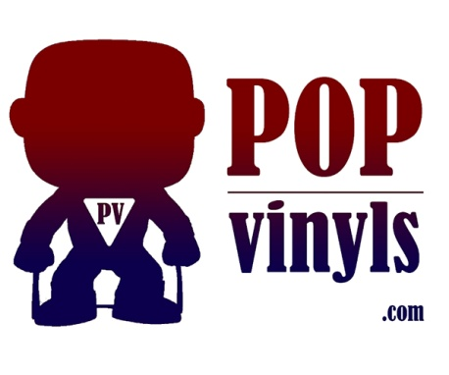
PopVinyls.com Hikari List

Revised March 2015
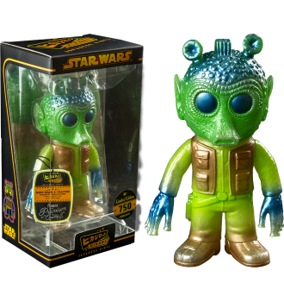
BATMAN HIKARI
Metallic Batman LE 1500
Classic Glitter Batman LE 1500
Gold Glitter Batman LE 500
NVS Batman LE 600
Silver Glitter Clear Batman LE 3000
Verdigris Batman LE 600
Sunrise Batman LE 300
(SDCC 2014 TOY TOKYO EXCLUSIVE)
Red Rain Batman LE 500 (SDCC 2014)
Ice Freeze Batman LE 500 (SDCC 2014)
TEENAGE MUTANT NINJA TURTLES HIKARI
Clear Glitter Donatello LE 3000
Clear Glitter Michaelangelo LE 3000
Clear Glitter Leonardo LE 3000
Clear Glitter Raphael LE 3000
Gold Glitter Ninja Turtle LE 500
(SDCC 2014)
Metallic Raphael LE 500
Metallic Donatello LE 500
Metallic Leonardo LE 500
Metallic Michelangelo LE 500 (NICKELODEON BOOTH SDCC 2014)
Metal Mix Leonardo LE 500
Pizza Power Michelangelo LE 600
Silver Glitter Raphael LE 500
Tie Dyed Leonardo LE 300 (SDCC 2014 TOY TOKYO EXCLUSIVE)
Mean & Green Raphel (SDCC 2014)
MASTERS OF THE UNIVERSE
Mystic Powers Skeletor LE 2000
Antique Classic Skeletor LE 300 (SDCC 2014 TOY TOKYO EXCLUSIVE)
Grey Skull Skeletor LE 1000
Mythos Skeletor LE 1000 (ENT EARTH)
Havoc Skeletor LE 2000
Metallic Skeletor LE 2000
24K Skeletor LE 600 (BOOKS A MILLION)
TRANSFORMERS
Optimus Prime
Optimus Prime Clear Glitter LE 3000
Battle Ready Optimus Prime LE 1000
(ENT EARTH)
24K Optimus Prime LE 600
(BOOKS A MILLION)
Distressed Optimus Prime LE 1000
Metallic Optimus Prime LE 2000
Dangerous Optimus Prime LE 600 (HT)
Bumblebee
Bumblebee Clear Glitter LE 3000
Battle Ready Bumblebee LE 1000
(ENT EARTH)
Distressed Bumblebee LE 1000
24K Bumblebee LE 600
(BOOKS A MILLION)
Metallic Bumblebee LE 2000
Dangerous Bumblebee LE 600 (HT)
UNIVERSAL MONSTERS HIKARI
Creature from the Black Lagoon
Apocalypse Creature LE 750
Gold Secret Base Creature: LE 500 (GEMINI)
NYCC Mythos Creature LE 500 (TOY TOKYO)
Original Creature LE 500
Secret Base Creature LE 1500
Bloody Terror Creature LE 500 (GEMINI)
Frankenstein’s Monster
Mystic Power Frankenstein LE 600
Mythos Frankenstein LE 750 (GEMINI)
Distressed Frankenstein LE 600
(ENT EARTH)
Glitter Shock Frankenstein LE 1200
Grey Skull Frankenstein LE 750 (TOYZOO)
Metallic Frankenstein LE 500 (GEMINI)
Vintage Frankenstein LE 1200
Platinum Frankenstein LE 750
Metaluna
Metaluna Mutant LE 1500
Retro Metaluna Mutant LE 750
GHOSTBUSTERS HIKARI
Toasted Stay Puft Marshmallow Man 11”
LE 1500
Pink Stay Puft Marshmallow Man 11”
LE 1000 (ENT EARTH)
Stay Puft Marshmallow Man 11” LE 1500
SPIDER-MAN HIKARI
Blaze Spider-man LE 1500
Dangerous Spider-man LE 1500
New Dimension Spider-man LE 1500
Metal Mix Spider-man LE 500
24K Spider-man LE 750
Mystic Powers Spider-man LE 1000
Distressed Spider-man LE 750
DEADPOOL HIKARI
Classic Deadpool LE 1500
Black and Red Deadpool LE 750
ASTRO BOY HIKARI
Classic Metallic Astro Boy LE 3000
NVS Blue Version Astro Boy LE 600
(ENT EARTH)
Metal Mix Astro Boy LE 1000
(ENT EARTH)
Pyro Astro Boy LE 88
(TOY TOKYO NYCC 2014)
Rice Candy Astro Boy LE 888
(TOY TOKYO NYCC 2014)
Distressed Astro Boy LE 2000
Gamma Blue Astro Boy LE 600
Infrared Astro Boy 750
GUARDIANS OF THE GALAXY HIKARI
11” Groot LE 5000
Green Groot LE 1500
Planet X Groot LE 1000 (ENT EARTH)
Distressed Groot LE 1000
GIGANTOR HIKARI
Original Gigantor LE 1300
Red Glitter Gigantor LE 500 (SOAP PLANT)
Black and Gold Gigantor LE 700
STAR WARS HIKARI
Boba Fett
Glitter Boba Fett LE 1200
Greedo
Original Greedo LE 2000
Sublime Greedo LE 750
Darth Vader
Lightning Darth Vader LE 1500
Clone Troopers
442 Siege Clone Trooper LE 900
Glitter 442nd Siege Clone Trooper LE 100
MISCELLANEOUS HIKARI
Green Creature Freddy LE 24
(FUNDAYS 2014)
Hopping Ghost Freddy LE 24
(FUNDAYS 2014)
Jiangshi Hopping Ghost LE 444
(SDCC 2014)
White Bone Demon LE 444
(NYCC TOY TOKYO 2014)
General Ku Lu Tou LE 444
(NYCC TOY TOKYO 2014)
Kappa Gold LE 88
(NYCC TOY TOKYO 2014)
Garuda LE 188
(NYCC TOY TOKYO 2014)
Brown Creature Freddy LE 1
(TOY TOKYO HALLOWEEN 2014)
Bloody Dragon King LE 4 (TOY TOKYO HALLOWEEN 2014)
Bloody Kappa LE 4 (TOY TOKYO HALLOWEEN 2014)
Pyro White Bone Demon LE 10 4 (TOY TOKYO HALLOWEEN 2014)
Pyro Jiangshi Sheriff LE 10 4 (TOY TOKYO HALLOWEEN 2014)
Pbyss General Ku Lu LE 10 4 (TOY TOKYO HALLOWEEN 2014)
This list is correct to the best of my knowledge. If you see a mistake, please let us know!

KEY: ( )- inside parentheses is where the exclusive could be found

* * between asterisks is the movie, tv show, game etc that a character appeared in.

[CHASE] – signifies a chase piece of a regular Pop. These items are harder to find and usually worth more.

This list is compiled, updated, and coyrighted by Matt Norris, owner of PopVinyls.com This document can be downloaded and printed as a checklist or used on a computer as a “clickable” checklist as long as the PopVinyls.com watermark and this addendum is kept intact giving full credit to its creator.

